Practical-11
Student Management CRUD with Search and Filter
Theory :
- Are SELECT, INSERT, UPDATE, and DELETE operations working?
Answer: Yes, all four database operations are working correctly to view, add, update, and delete records.
- Is search by name/email/course implemented?
Answer: Yes, the search functionality allows users to find records using name, email, or course.
- Are delete operations confirmed before execution?
Answer: Yes, a confirmation message is displayed before deleting a record to prevent accidental deletion.

Result:

1)Sample data for student record
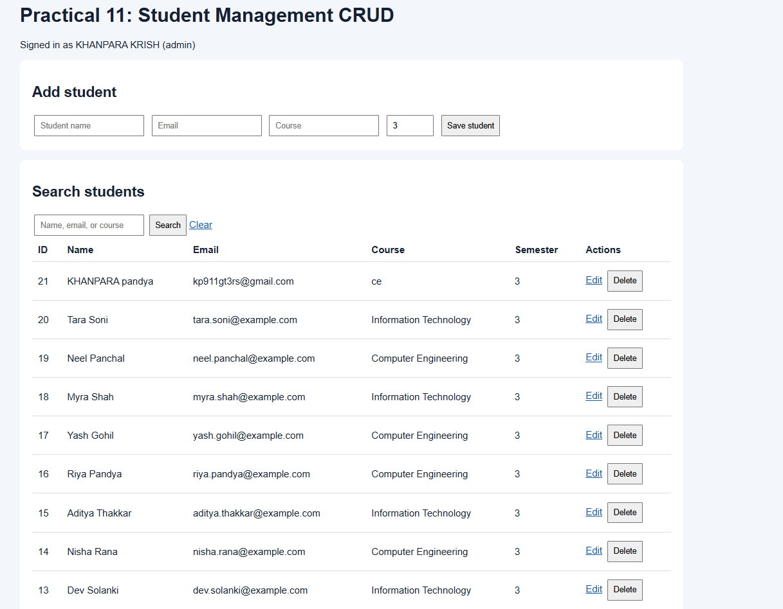

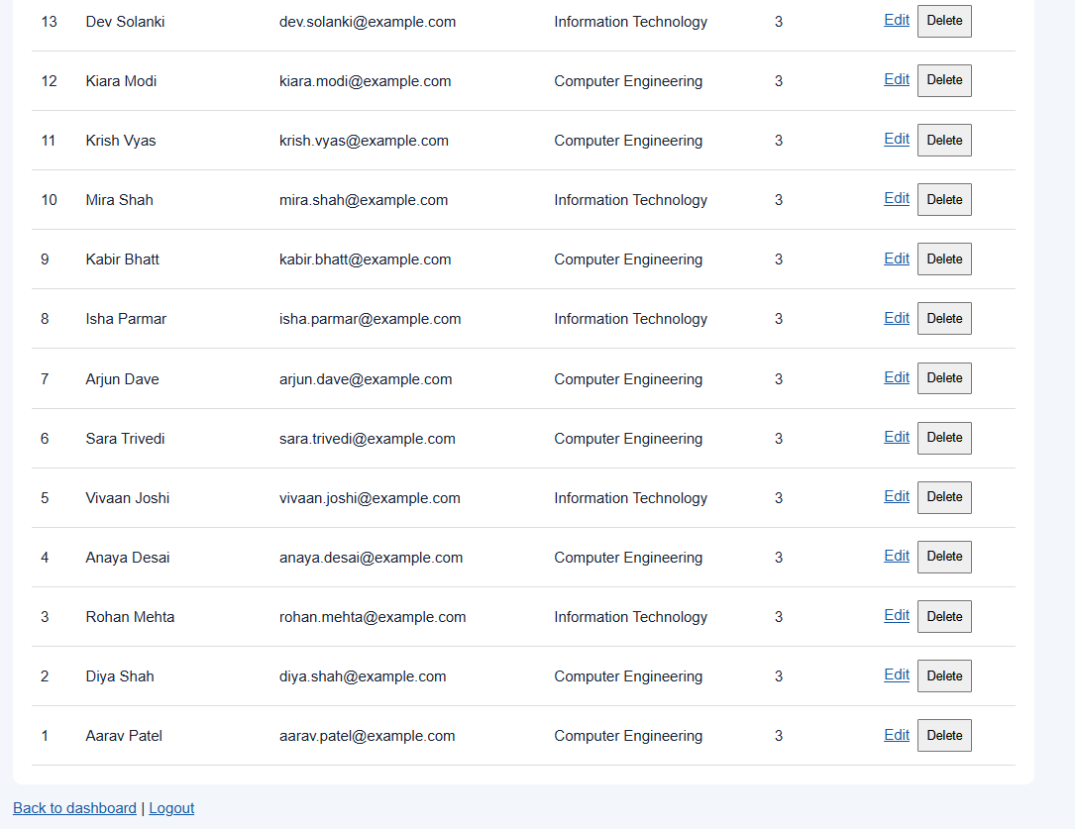

2) student panel
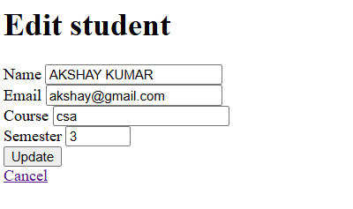

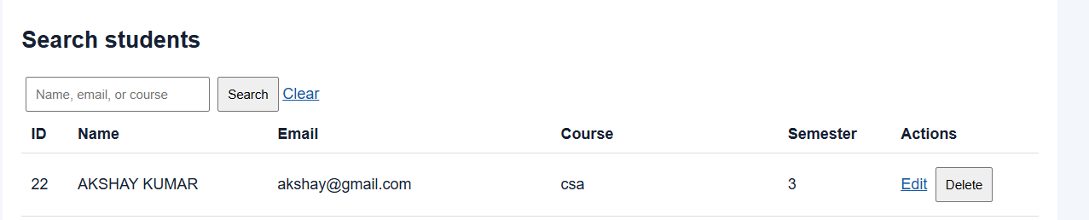

Git Hub Repository Link:
https://github.com/25dce046/STUDENT-HUB-PORTAL

Challenges Faced: I faced difficulties in implementing CRUD operations using PHP and MySQL. I struggled with implementing search and filter functionality for student records. I also faced challenges in handling delete confirmations and displaying success or failure messages.
Learning Outcome:- I learned to perform INSERT, SELECT, UPDATE, and DELETE operations using PHP and MySQL.
I understood how to implement search and filter functionality for student records. I also learned to handle user confirmations and display appropriate messages after database operations.

